Setup of the Grandstream GXP1625 And How to Use
Section 1: Physical Setup
- Begin by removing everything from the box. Then, attach the stand to the back of the main base.
- Next, connect the phone cord (swirled string) to the main base and then to the handset of the phone. Place the handset onto the receiver spot.
- Next, connect the Ethernet cable to either the POE port or the regular Ethernet port. Finally, connect the power block and cord to the circular spot in the middle.
- Plug your Ethernet cord into the internet block that you are using and the power block into an outlet. It should now power on.
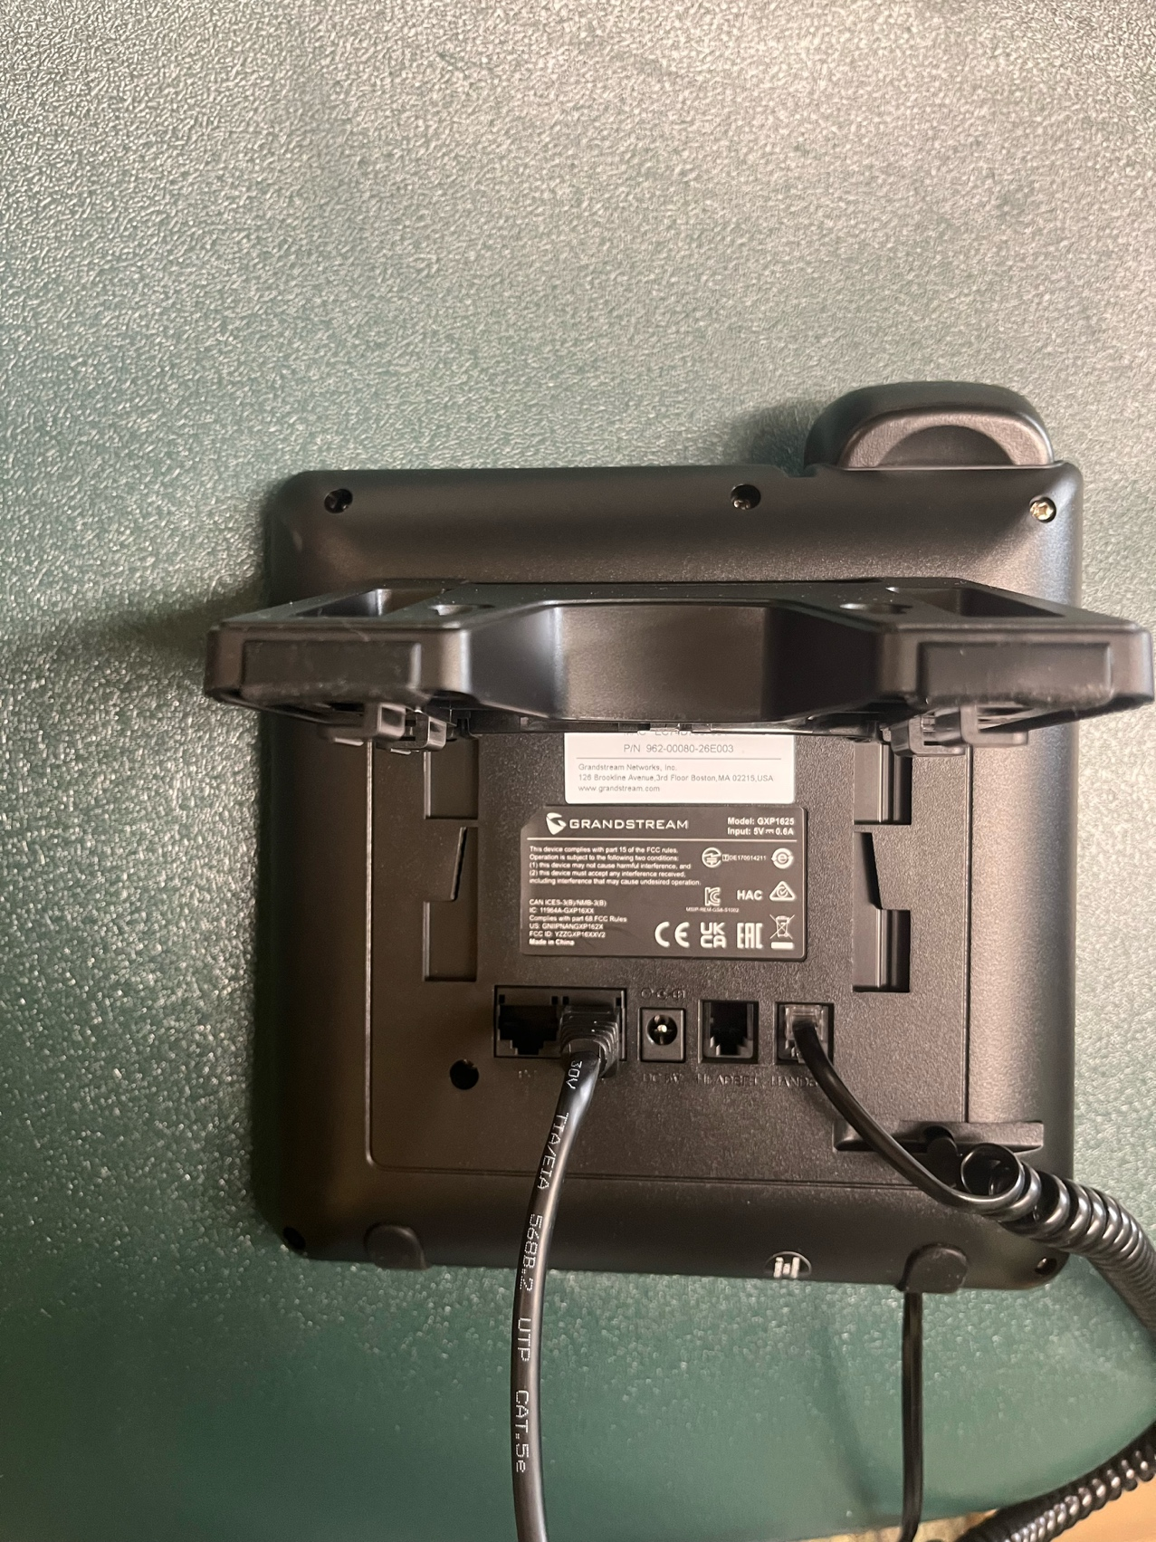
Finished Setup:

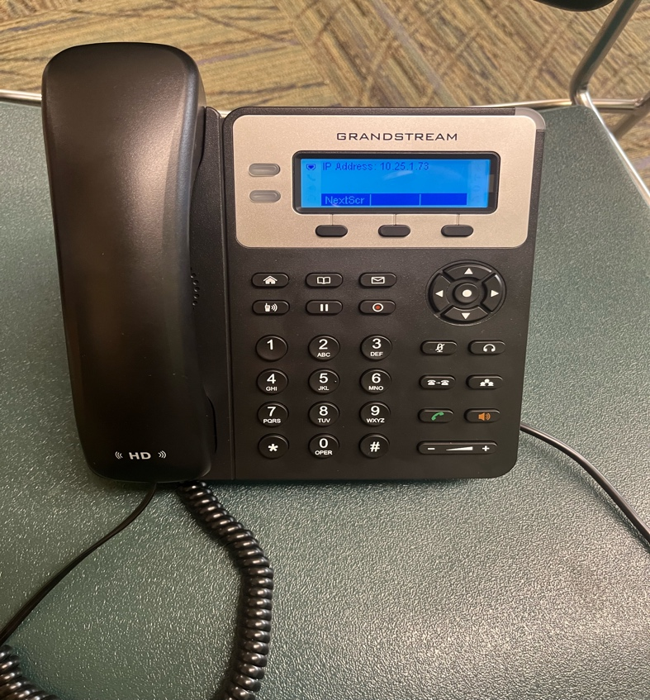
Section 2: How to Use Phones
- Phone Overview

Key Parts
- LCD Screen – Displays call info, time, and menus
- Soft Keys – Buttons under the screen that change function
- Line Keys (2) – Used for active lines/accounts
- Navigation Keys – Up/down/left/right + OK
- Dial Pad – Standard number keypad
- Speaker Button – Enables speakerphone
- Headset Button – Activates headset mode
- Mute Button – Mutes microphone
- Volume Keys – Adjust ringer/call volume

2. Making Calls
Method 1: Handset
- Pick up the handset
- Dial the number
- Wait for the call to connect

Method 2: Speakerphone
- Press the Speaker button
- Dial the number
- Speak hands-free

Method 3: Pre-Dial
- Enter the number while on-hook
- Press Dial or lift the handset

3. Answering Calls
- Handset: Pick up the handset
- Speaker: Press the Speaker button
- Headset: Press the Headset button

4. Ending Calls
- Hang up the handset
- OR press End Call soft key
- OR press the Speaker/Headset button

5. Call Features
Hold
- Press Hold during a call
- Press Resume to return

Mute
- Press Mute to silence your microphone
- Press again to unmute

Transfer Call
Blind Transfer (immediate)
- Press Transfer
- Dial the number
- Press Transfer again

Attended Transfer (announce first)
- Press Transfer
- Dial the number
- Wait for answer
- Press Transfer again

Conference Call (3-way)
- During a call, press Conference
- Dial the second number
- Press Conference again to join all parties

6. Call History
View Call Logs
- Press Menu
- Select Call History
- Choose:
  - Missed Calls
  - Received Calls
  - Dialed Calls

Redial
- Press the Redial button to call the last number

7. Contacts (Phonebook)
Access Contacts
- Press Menu
- Select Phonebook

Add Contact
- Go to Phonebook
- Select Add Contact
- Enter name and number
- Save

Call a Contact
- Open Phonebook
- Select contact
- Press Dial

8. Volume Control
- During a call: adjusts call volume
- When idle: adjusts ringer volume

9. Ringtones
- Press Menu
- Go to Preferences → Ring Tone
- Select a tone
- Save

10. Do Not Disturb (DND)
- Press the DND soft key to enable
- Press again to disable
When enabled, incoming calls will not ring
11. Troubleshooting
No dial tone
- Check network connection
- Ensure phone is registered
Can’t hear audio
- Check volume
- Ensure correct device (handset/speaker/headset)
Calls not going through
- Verify account/SIP registration with admin

12. Quick Tips
- Use Redial for speed
- Use Hold + Transfer for call handling
- Keep volume adjusted to avoid missed calls
- Learn soft key labels—they change depending on context

